**3. Requirements Analysis**

**3.1 Customer Journey map**

The Customer Journey Map for the *Pattern Sense* project outlines the end-to-end experience of a typical user interacting with the fabric pattern classification system. It helps identify user needs, emotions, and touchpoints across each phase of interaction, ensuring the product is user-centric and solves real problems effectively.

👤 Persona: Fabric Designer / Fashion Student

* Name: Priya
* Age: 21
* Background: Fashion design student working on a project that involves identifying fabric types.
* Goal: Quickly determine the pattern type (e.g., striped, polka-dotted) of fabric images to categorize her collection accurately.

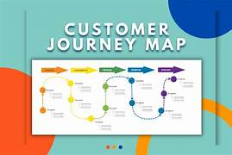

**🎯 Insights from the Customer Journey**

* **Pain Points Identified**:
  + User confusion if result is delayed or unclear.
  + Lack of confidence if model predictions aren't explained.
* **Opportunities for Improvement**:
  + Add prediction confidence level and visual feedback.
  + Provide basic pattern information for education.
  + Ensure UI is clean, responsive, and intuitive.